**DAILY ONLINE ACTIVITIES SUMMARY**

|  |  |  |  |  |  |  |  |  |
| --- | --- | --- | --- | --- | --- | --- | --- | --- |
| **Date:** | 13-06-2020 | | | | | **Name:** | Anvitha H M | |
| **Sem & Sec** | 4th ‘A’ | | | | | **USN:** | 4AL18CS010 | |
| **Online Test Summary** | | | | | | | | |
| **Subject** | | Data communication | | | | | | |
| **Max. Marks** | | 30 | | **Score** | | | 24 | |
| **Certification Course Summary** | | | | | | | | |
| **Course** | Front end development - CSS. | | | | | | | |
| **Certificate Provider** | | | Great learning academy | | **Duration** | | | 8 hours |
| **Coding Challenges** | | | | | | | | |
| **Problem Statement: C** program to calculate the electricity bill. | | | | | | | | |
| **Status:** Executed | | | | | | | | |
| **Uploaded the report in Github** | | | | | YES | | | |
| **If yes Repository name** | | | | | <https://github.com/alvas-education-foundation/Anvitha-H-M> | | | |
| **Uploaded the report in slack** | | | | | Yes | | | |

**Online test:**

It was from module 1 and 2, the test was for 30 minutes having 30 question all multiple choice question. The questions were simple and optimal and the score that I got was 24/25.

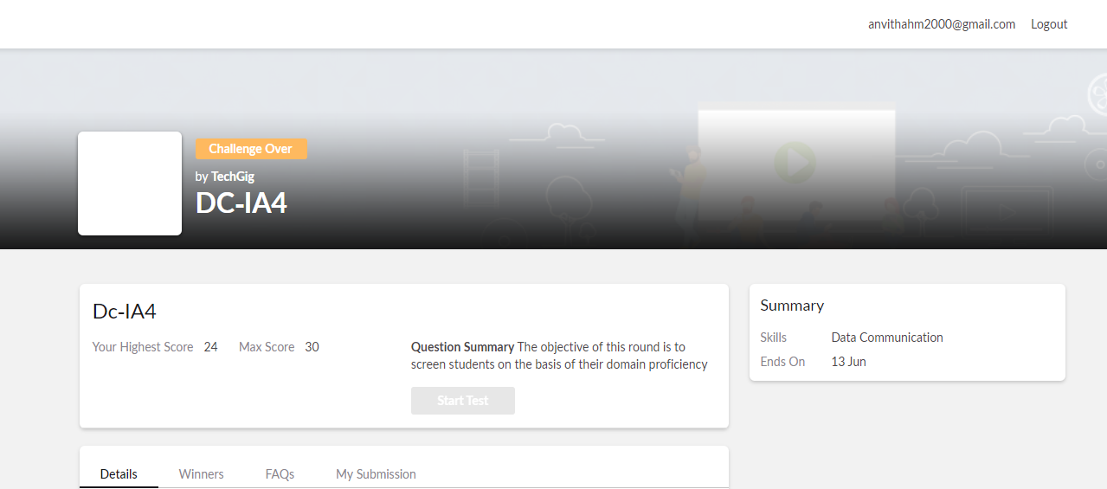

**Certification course:**

Front end development - CSS

The course includes detailed explanation on default browser style, inheritance in CSS, CSS non-inherited properties, cascade with embedded styling and external, inline stylesheet, specifity type vs class selector and type vs class vs ID with exercising quiz.

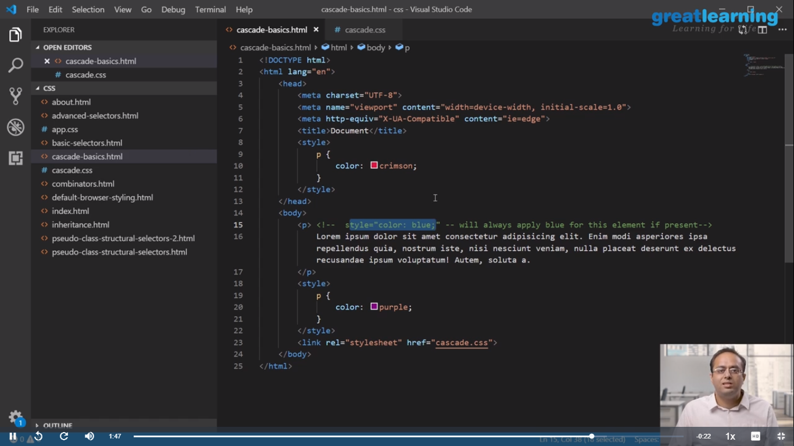

Online coding challenge

The programing statement of the day is

“Program in C to calculate the electricity bill”.

Solution: Executed and uploaded in Github repository.

Link: <https://github.com/alvas-education-foundation/Anvitha-H-M>

